Merry Mayhem Concept Document
Most Oldest People

Summary
Merry Mayhem is a linear, top down, isometric, twin stick shooter focused on nonstop fighting. The universal title of “Master of Chaos” is up for grabs and the player (Pax) is the perfect hellion for the job but she is not the only badass in the universe seeking the position. The player embarks on a journey to exotic, peaceful realms to wreak havoc and prove they have all the makings of a great Master of Chaos. The player strategically makes use of special attacks in tandem with their standard abilities, to smash through hordes of peaceful inhabitants that defend their realm from the pandemonium she seeks to create.
High Concept
Traveling to unique and unknown worlds to wreak havoc and destruction upon the weak creates moments of sadistic, empowerment and triumph.
Narrative Overview
The current Master of Chaos is going into retirement and is looking for one of his protégés to fill the position, but this is far from a normal interview process. Any potential successor must first prove they have what it takes to strike fear and pandemonium throughout the realms. Pax, origin unknown. With her spit fire spirit and her penchant for all things chaotic, the Master of Chaos sends her a personal invitation to his throne room. Suiting up with weapons of the trade, Pax is sent to bizarre peaceful realms to cause mass destruction and give the innocent a taste of DANGER!

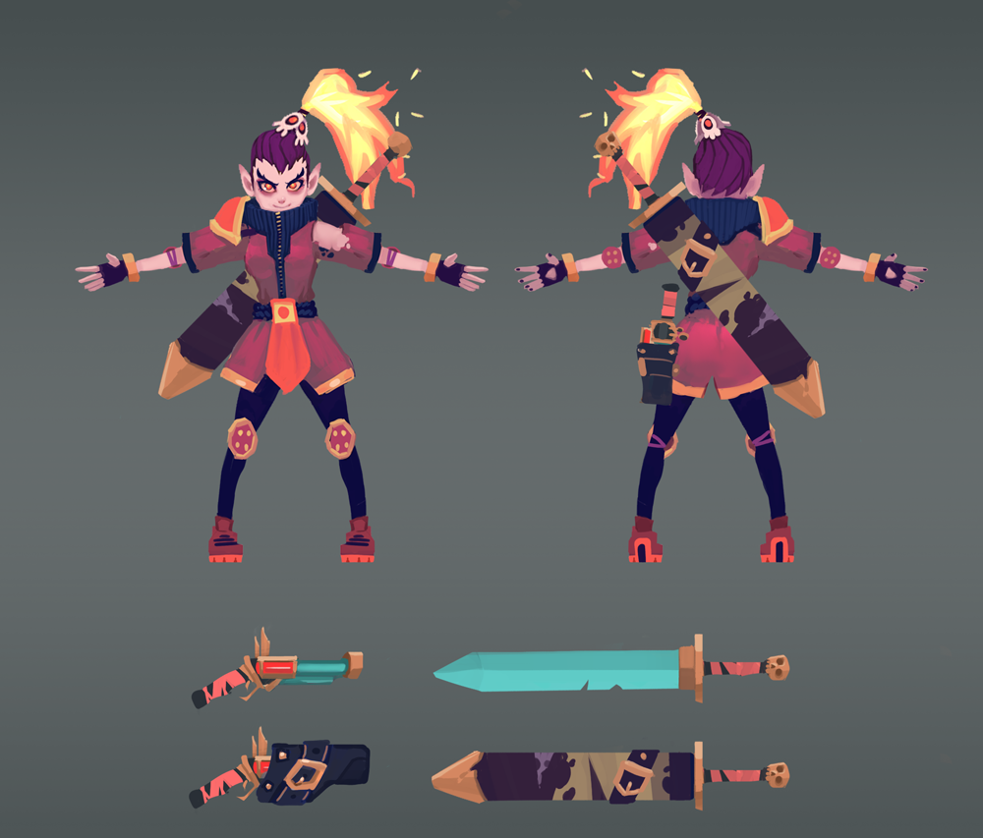
Character and weapons concept for main character, Pax.
Mechanical Features
Pax is equipped two weapons: a sword which is used for close range melee attacks and a gun for long range attacks. Pax is also endowed with some unique powers which allow for her to have up to three abilities during play.
As the player progresses to each new world, they will encounter a specific blockage within the environment, where new abilities may be learned. The newly acquired ability adds an element of combat advantage over the enemies within each world.

Enemy Types
Each enemy begins as either one of three main classes and may inherit one of three subclass listed below:
Main Classes
Subclasses | Melee  Enemies that chase the player. | Ranged  Enemies with projectile attacks. | Heavy  (Physically Large)  Heavy, cannot be moved by special abilities.
Area of Effect  Low health, faster speed. Leaves a hazard that hurts the player for a short duration upon death. | Suicide bomber that charges the player and blows up. | Shoots toxic bullets that fan out. | N/A
Berserker  High damage, low health. Has a second life. | Second life - higher damage, fast speed. | N/A | Second life - higher attack speed, triangle spray.
Shield  Negates physical attacks, lowers enemy speed. | N/A | Shoots mid-ranged while shielded. Vulnerable in the back. | Low speed, high damage.

Special Abilities
Pax learns one of the following special abilities at the beginning of each world:
- Gravity Trap - Pax sets this trap. Upon detonation an area of effect will trigger radially. All non-heavy enemies or special environmentals within in this radius will be pulled toward the center. Gravity Trap does not affect Pax.

- Sword Tornado - With her sword, Pax rapidly spins damaging non shielded enemies.

- Flame On - The player aims the attack. Pax’s hair becomes engulfed in flames that rain down fireballs onto the area the player aimed for. Armored enemies are stripped of their armor, but receive no damage while all other enemy types are hurt.
Skill Tree
Upon completing each world, Pax is rewarded with an option to upgrade one of three stats relating to herself and her weapons Pax, Sword, and Gun. Pax is only given one point to spend in the skill tree upon completion of a world. The player is able to read what each level of the skill tree contains at all times but is only able to access advanced upgrades by first unlocking the level before it. These potential upgrades are represented by a skill tree and are listed below.

Skill Tree
 | Pax | Sword | Gun
Level 1 | Frugal Finger  Health pickups regenerates twice as much HP. | Lofty Sway  Extended melee range | Snap Snap  Faster Reload time
Level 2 | Mad Dash  Pax’s dash stuns enemies | Quicktime  Reduced melee swing Cool Down | Trigger Happy  Every bullet fired has a chance to fire an additional bullet at no extra cost of ammunition.
Level 3 | Fire Cloak  AOE fire damage around Pax | Buster Blade  Charge your sword by holding down the attack trigger and release it to deal extra damage | Wipe Out  When firing, your shots have a chance to convert into a shotgun blast, with each projectile dealing damage equal to a normal bullet

Aesthetic Features
Each alternate world that Pax explores contains unique styles colors and content.
Unique Worlds
Pax encounters three distinct locations to conquer which are as follows:
- Candy Land - A land composed of pastel colors. Most of the structures are made out of candy, and cake. Enemies will also be made out of candy.
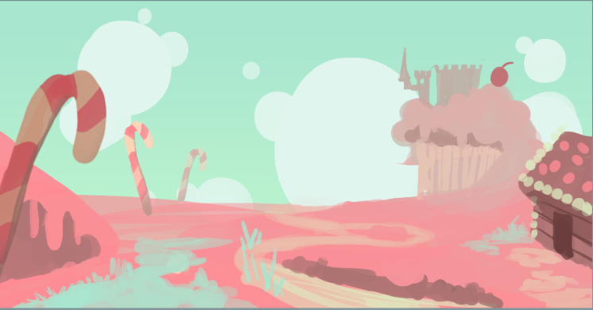
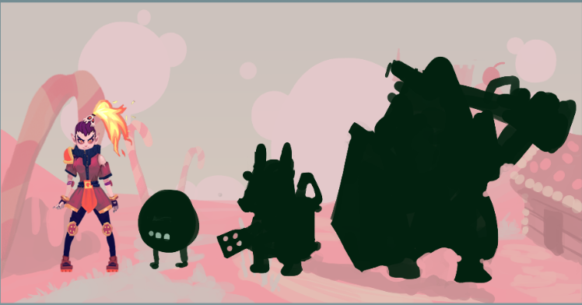
Candy Land’s rough concept with 3 monster silhouettes. Melee, Ranged, and Heavy

- Plant Land - A land composed of earth tones. Structures made out of trees, and other natural materials. Enemies will be plant-like, or plant inspired.
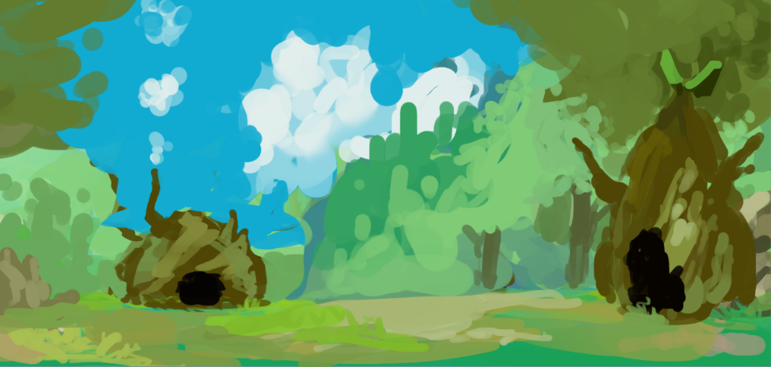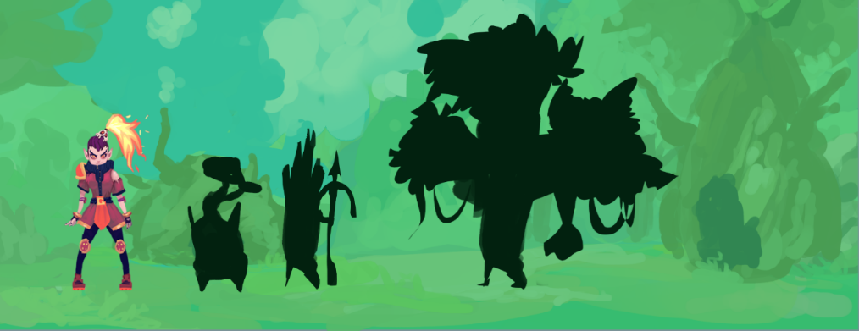
Plant Land’s rough concept with 3 monster silhouettes. Melee, Ranged, and Heavy

- Alien Cowboys Land- A land composed of warm colors with splashes of cool colors. Structures will be made out of metallic cool materials. Enemies will be extraterrestrial in appearance, and will contrast the warm colors of the floor with their cool colored armors.
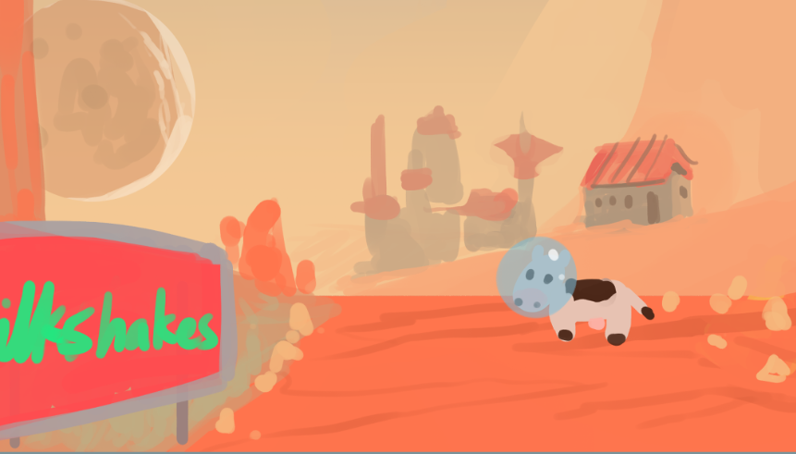
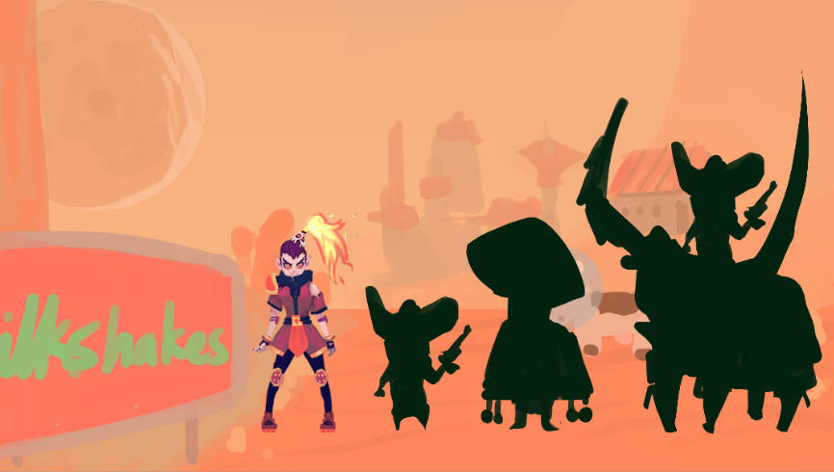
Alien Cowboys Land rough concept of environment. Concept of 3 monster silhouettes.

- Throne Room - A room with a big throne, and three doors.
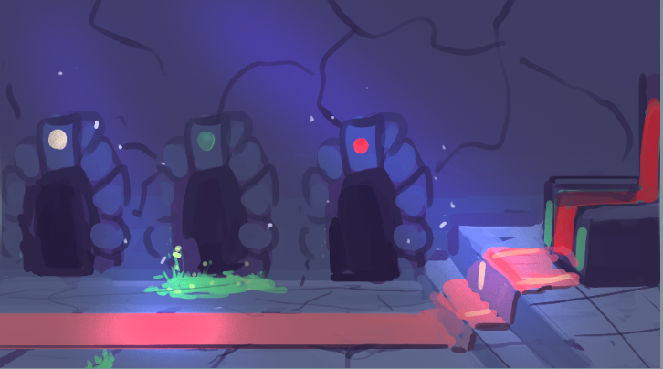
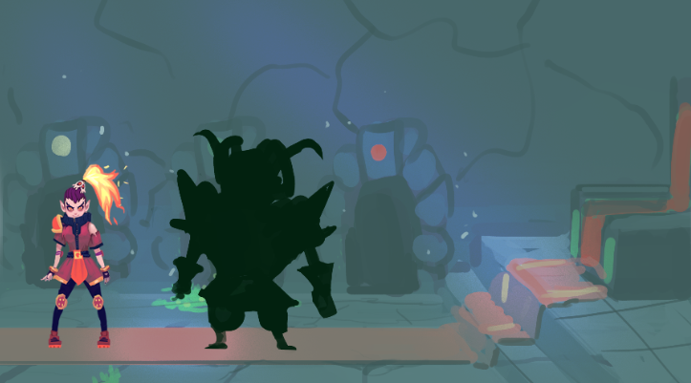
Throne Room rough concept. Concept of the Master of Chaos’s Silhouette.

